Theoretical Research on Quantum Storage Using Solid State Drives

Authors:

Bhavesh Naidu Kulluru

*Department of Computer Science and Information Systems*

*Saginaw Valley State University*

University Center, United States of America

[bkulluru@svsu.edu](mailto:jrreiner@svsu.edu)

Sai Dheeraj Ravipati

*Department of Computer Science and Information Systems*

*Saginaw Valley State University*

University Center, United States of America

[sravipat@svsu.edu](mailto:jrreiner@svsu.edu)

Co-Author:

Aos Mulahuwaish

*Department of Computer Science and Information Systems*

*Saginaw Valley State University*

University Center, United States of America

amulahuw[@svsu.edu](mailto:jrreiner@svsu.edu)

Abstract

This research paper aims to gather information on how Solid State Drive’s (SSD) can be used for storage of Quantum bits or Q-bits. And to evaluate whether SSD’s can be used as an efficient storage mechanism for the fourth coming generations of quantum computers.

This research explores the feasibility of utilizing Solid State Drives (SSDs) for storing quantum bits (qubits) and evaluates their potential as an efficient storage mechanism for future generations of quantum computers. By analyzing the underlying principles of SSDs and qubits, the research aims to establish a functional architecture model that bridges the gap between these two distinct storage mechanisms. The proposed architecture incorporates a separate storage module within an SSD, specifically designed to accommodate qubits alongside conventional bits. This integrated approach enables synchronous access to both types of data, facilitating seamless computation in quantum computing environments.

Introduction

The advent of quantum computing has ushered in a new era of technological advancement, promising to revolutionize fields ranging from medicine and materials science to artificial intelligence and cryptography. At the heart of quantum computing lies the concept of quantum bits or qubits, which can exist in a superposition of states, simultaneously representing both 0 and 1. This unique property enables quantum computers to perform computations that are intractable for classical computers.

As quantum computing technology matures, the need for efficient storage mechanisms for qubits has become increasingly crucial. Conventional storage devices, such as hard disk drives and solid state drives (SSDs), are primarily designed to store classical bits, represented as either 0 or 1. While these devices have demonstrated remarkable performance and capacity for classical data storage, they face significant challenges when it comes to storing and managing qubits.

The inherent quantum properties of qubits make them highly sensitive to environmental disturbances, leading to decoherence, a phenomenon that causes the superposition state of qubits to collapse, rendering them indistinguishable from classical bits. This sensitivity poses a major obstacle in maintaining the integrity of quantum information during storage and retrieval.

To address these challenges, researchers are exploring alternative storage solutions specifically tailored for qubits. One promising approach involves utilizing SSDs, which offer several advantages over conventional storage devices. SSDs employ flash memory cells, which store data as trapped electrons, making them less susceptible to mechanical vibrations and electromagnetic interference compared to hard disk drives. Additionally, SSDs offer faster read and write speeds, which are critical for maintaining the coherence of qubits.

This research project aims to investigate the feasibility of using SSDs to store qubits and evaluate their potential as an efficient storage mechanism for future generations of quantum computers. The project will focus on developing a novel architecture model that integrates a separate storage module for qubits within an SSD. This integrated approach will enable synchronous access to both conventional bits and qubits, facilitating seamless computation in quantum computing environments.

The proposed architecture will utilize a specialized memory layer within the SSD, specifically designed to accommodate the unique properties of qubits. This memory layer will incorporate error correction mechanisms to mitigate the effects of decoherence and ensure the integrity of stored qubits. Additionally, the architecture will incorporate a control logic module responsible for managing data transfer between the qubit storage layer and the classical processing unit.

The successful development of this integrated qubit storage architecture will pave the way for the advancement of quantum computing technology, enabling the realization of its full potential in various scientific and engineering disciplines. By providing a reliable and efficient storage solution for qubits, this research will contribute to the development of next-generation quantum computers capable of solving complex problems that are currently intractable for classical computers.

Literature Review

Despite the rapid advancements in quantum computing technology, there is a noticeable lack of research on the use of SSDs for storing qubits. A brief literature survey on IEEE from the 1880s to 2023 yielded only one result that covered both SSDs and qubits. This scarcity of research can be attributed to several factors.

**Challenges in Storing Qubits**

Qubits are inherently sensitive to environmental disturbances, making them difficult to store and manipulate. Conventional storage devices, such as SSDs, are primarily designed to store classical bits, which are less susceptible to these disturbances. As a result, researchers have faced significant challenges in adapting SSDs to accommodate the unique properties of qubits.

**Decoherence**

One of the primary challenges in storing qubits is decoherence, a phenomenon that causes the superposition state of qubits to collapse, rendering them indistinguishable from classical bits. Decoherence can be caused by various factors, such as temperature fluctuations, electromagnetic interference, and mechanical vibrations. SSDs, despite their advantages over hard disk drives, are not entirely immune to these disturbances.

**Error Correction**

To mitigate the effects of decoherence, researchers have developed error correction mechanisms. However, implementing these mechanisms in SSDs poses additional challenges due to the inherent limitations of flash memory technology. The trade-off between error correction overhead and storage capacity becomes particularly critical in the context of SSDs.

**Opportunities**

Despite these challenges, there are several reasons to believe that SSDs have the potential to become an efficient storage mechanism for qubits. SSDs offer several advantages over conventional storage devices, including faster read and write speeds, lower power consumption, and greater resilience to mechanical shocks. Additionally, the continuous advancements in flash memory technology are likely to further improve the performance and reliability of SSDs, making them even more suitable for qubit storage.

**Research Directions**

To address the challenges and explore the opportunities in using SSDs for storing qubits, several research directions can be pursued.

Development of Novel Flash Memory Cells: Researchers can investigate the development of novel flash memory cells specifically designed to minimize decoherence and enhance the coherence time of stored qubits.

Integration of Error Correction Mechanisms: Efficient error correction mechanisms tailored for the unique characteristics of SSDs need to be developed to ensure the integrity of stored qubits.

Optimization of Data Transfer Protocols: Data transfer protocols between the qubit storage layer and the classical processing unit need to be optimized to minimize latency and maximize throughput.

Evaluation of Performance and Scalability: The performance and scalability of SSD-based qubit storage architectures need to be evaluated through rigorous experimentation and simulation.





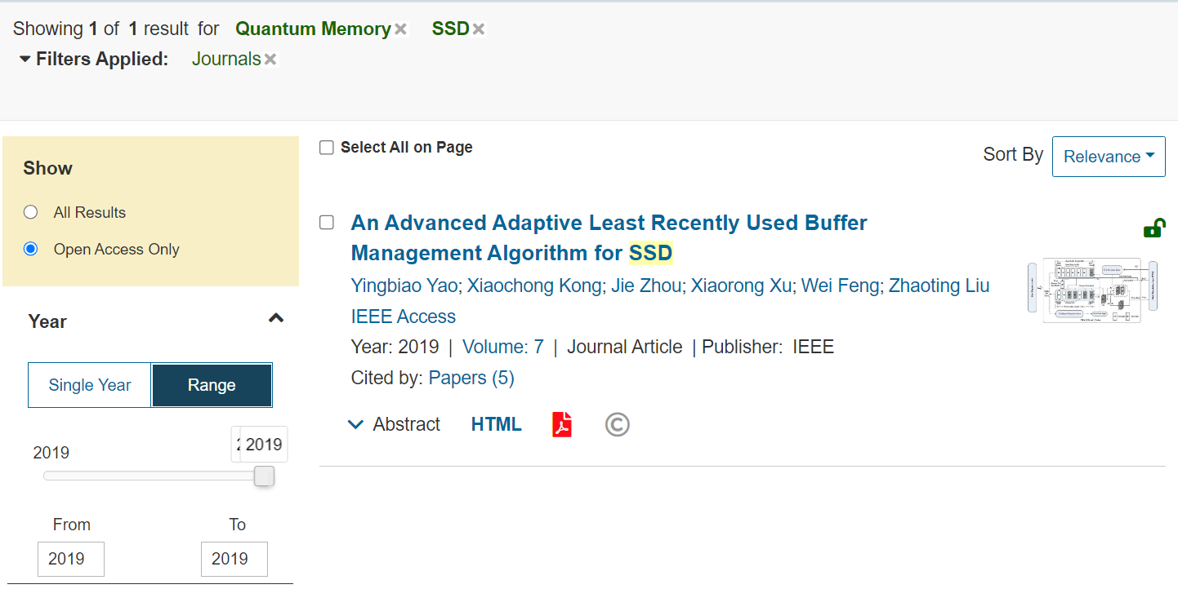

Deep-Dive Analysis:

**Quantum tunneling**

Quantum tunneling is a phenomenon that allows a particle to pass through a barrier that it would not be able to penetrate in the classical world. This is because the particle's wave function can extend into the barrier, allowing it to leak through with a certain probability.

Quantum tunneling is responsible for a number of important phenomena, such as alpha decay and the operation of tunnel diodes. It is also a key ingredient in many quantum technologies, such as scanning tunneling microscopes and superconducting quantum computers.

It is a key mechanism in the operation of solid-state drives (SSDs). In SSDs, quantum tunneling allows electrons to move between floating gates, which are small islands of conducting material embedded in a layer of insulating material. This movement of electrons is used to store data, with the presence or absence of an electron on a floating gate representing a 1 or 0, respectively.

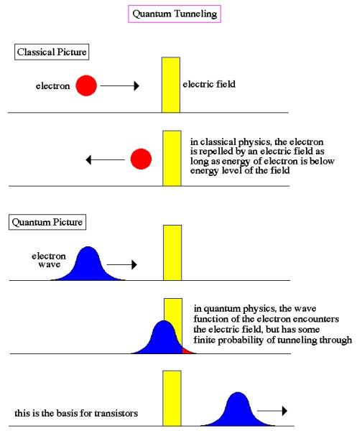

**SSDs**

Solid-state drives (SSDs) are a type of storage device that uses flash memory to store data. Flash memory is a type of semiconductor memory that stores data in the form of electrons trapped in floating gates. This makes SSDs more resistant to shock and vibration than hard disk drives (HDDs), which use spinning disks to store data. SSDs also have faster read and write speeds than HDDs.



Several types of flash memory are used in SSDs, including single-level cell (SLC), multi-level cell (MLC), and triple-level cell (TLC). SLC flash memory stores one bit of data per cell, MLC flash memory stores two bits of data per cell, and TLC flash memory stores three bits of data per cell. TLC flash memory is the most cost-effective type of flash memory, but it also has the shortest lifespan.

**Flash memory**

Flash memory is a type of non-volatile semiconductor memory that can be electrically erased and reprogrammed. It is used in a wide variety of devices, including solid-state drives (SSDs), USB flash drives, and embedded memory.

Flash memory stores information in memory cells that use floating-gate transistors to store and retrieve data. In single-level cell (SLC) devices, each cell stores only one bit of information. Multi-level cell (MLC) devices, including triple-level cell (TLC) devices, can store more than one bit per cell.

To write data to a flash memory cell, a high voltage is applied to the control gate, which causes the electrons in the channel to tunnel into the floating gate. This traps the electrons in the floating gate, and the cell is said to be programmed. To erase a flash memory cell, a high voltage is applied to both the control gate and the source, which causes the electrons in the floating gate to tunnel out of the channel.

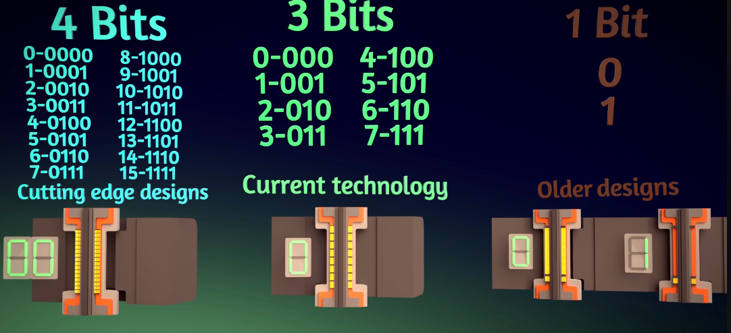

**V-NAND**

V-NAND (Vertical NAND) is a type of 3D NAND flash memory that stacks the memory cells vertically instead of horizontally. This allows for more memory to be stored in a smaller space, making it a more efficient and cost-effective type of flash memory.

V-NAND works by stacking multiple layers of memory cells on top of each other. Each layer of memory cells is connected to a control gate, which is used to read and write data. When a voltage is applied to the control gate, it allows electrons to tunnel into or out of the memory cell. The presence or absence of an electron in a memory cell represents a 1 or 0, respectively.

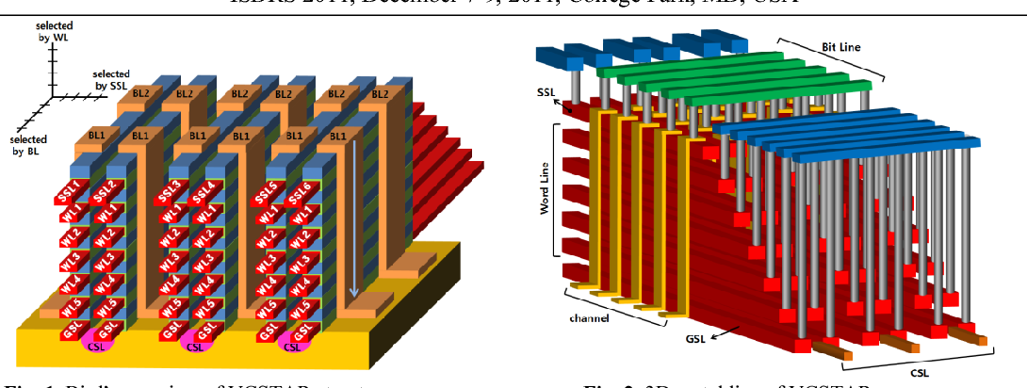

**Charge Trap Flash Memory**

Charge trap flash memory (CTF) is a type of non-volatile semiconductor memory that uses a thin layer of silicon dioxide (SiO2) to store data. CTF cells are similar to floating gate flash cells, but instead of a floating gate, they have a charge trap layer. This layer is made of a material that can trap electrons, which is used to store data.

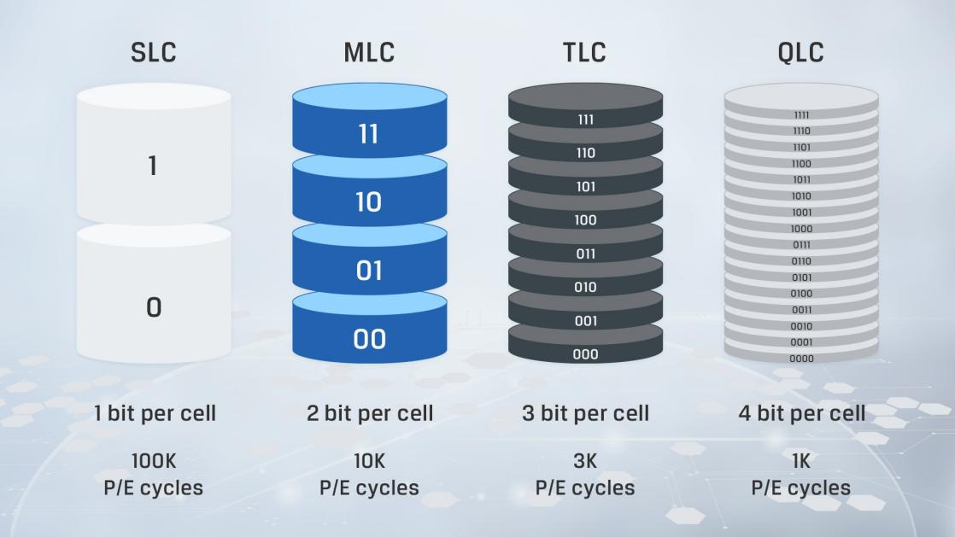

SSDs are becoming increasingly popular as storage devices for computers, smartphones, and other electronic devices. This is due to their faster read and write speeds, lower power consumption, and greater resilience to mechanical shock.

**Quantum-Superposition**

In the realm of quantum mechanics, where the rules of physics seem to defy common sense, lies the enigmatic concept of quantum superposition. This mind-boggling principle states that a quantum system, such as an electron or a photon, can exist in multiple states simultaneously until it is measured.

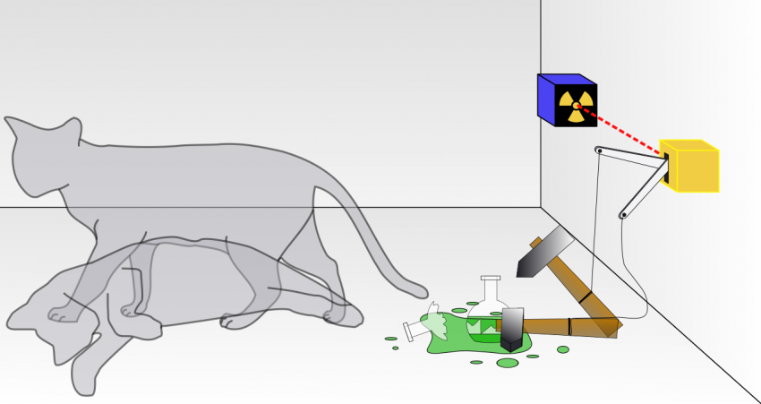

Quantum superposition is a fundamental principle of quantum mechanics that states that a quantum system can exist in multiple states simultaneously until it is measured. This means that a particle can be in two places at the same time, or have two different spins at the same time.

Quantum superposition is one of the key ingredients in quantum computing, a revolutionary new type of computing that has the potential to solve problems that are intractable for classical computers. Quantum computers use qubits, which are quantum systems that can exist in a superposition of states, to perform calculations.

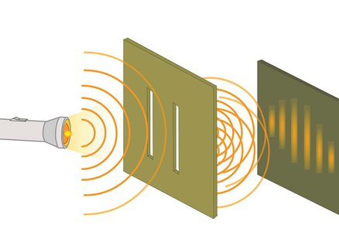

**The double-slit experiment**

The double-slit experiment is one of the most famous and important experiments in physics. It demonstrates that light and matter can both behave as waves and particles, and it provides evidence for the wave-particle duality of quantum mechanics.

In the double-slit experiment, a beam of light is passed through two narrow slits in a barrier. The light then spreads out and interferes with itself, creating a pattern of bright and dark bands on a screen behind the barrier.

This pattern is only possible if light behaves as a wave. If light were simply a stream of particles, there would be no interference pattern, and the screen would be uniformly lit.

The double-slit experiment is also important because it shows that the act of observing light can affect its behavior. When light is observed, it behaves as a particle and travels in a straight line. When light is not observed, it behaves as a wave and spreads out.

This is a strange and counterintuitive result, but it is a fundamental part of quantum mechanics. It means that the reality of the world is not fixed and predetermined, but rather exists in a state of flux, a probabilistic dance of possibilities.

**Qubits**

Quantum bits, or qubits, are the basic unit of information in quantum computing. Unlike classical bits, which can only be 0 or 1, qubits can exist in a superposition of states, meaning that they can be both 0 and 1 at the same time. This property allows quantum computers to perform computations that are impossible for classical computers.

Qubits are very sensitive to environmental disturbances, which can cause them to decohere and lose their superposition state. This makes it difficult to store and manipulate qubits. Several techniques are being developed to mitigate decoherence, such as error correction and cryogenic cooling.

**Integration of SSDs and Qubits**

Researchers are investigating the possibility of using SSDs to store qubits. SSDs offer several advantages over conventional storage devices, such as faster read and write speeds, lower power consumption, and greater resilience to mechanical shock. However, there are several challenges that need to be addressed before SSDs can be widely used for qubit storage.

One of the main challenges is decoherence. Qubits are very sensitive to environmental disturbances, and the high-speed operation of SSDs can generate noise that causes decoherence. Researchers are developing error correction mechanisms to mitigate decoherence, but these mechanisms can add overhead and reduce the storage capacity of SSDs.

Another challenge is the need for a specialized memory layer within the SSD to accommodate the unique properties of qubits. This memory layer would need to be able to store qubits in a superposition of states and protect them from decoherence.

Despite these challenges, there is significant potential for using SSDs to store qubits. SSDs offer several advantages over conventional storage devices, and the continuous advancements in flash memory technology are likely to further improve their performance and reliability. With continued research and development, SSDs could become a viable storage solution for quantum computers.

The integration of SSDs and qubits is a promising area of research that could have a significant impact on the development of quantum computing technology. By addressing the challenges of decoherence and developing specialized memory layers, researchers could make SSDs a viable storage solution for quantum computers. This would enable the realization of more powerful and efficient quantum computers, capable of solving complex problems that are currently intractable for classical computers.

Conclusion

Our research explores a new idea: using Solid State Drives (SSDs) to store quantum bits or qubits. This is a unique approach in the world of quantum computing.

Our review found very little existing research on this topic. We learned that storing qubits is tricky because they are easily affected by their surroundings, a problem known as decoherence. Despite this challenge, SSDs, known for their fast speeds and durability, offer some exciting possibilities.

Our suggested method involves a special part in the SSD designed just for qubits. This design aims to tackle the specific challenges qubits pose during storage. It could open the door to smoother quantum computing where both regular bits and qubits can work together seamlessly.

Looking deeper into the details, we explored concepts like quantum tunneling, how SSDs work, and the peculiar nature of qubits existing in multiple states at once.

Looking ahead, our proposed directions for future research include creating better memory cells, developing efficient error correction, optimizing data transfer, and testing how well SSDs can handle quantum storage.

In conclusion, blending SSDs with qubits has exciting potential for the future of quantum computing. Our research contributes to this growing field, suggesting that if we can make this integration work, it might lead to powerful quantum computers solving problems that regular computers can't. This is like building a bridge between our current computers and the future of quantum information storage.

Acknowledgement

The completion of this paper would not have been possible without the guidance and support of several individuals and the groundbreaking work of pioneering scientists. I would like to express my sincere gratitude to my professor, Mr. Aos Mulahuwaish, for his invaluable advice and encouragement throughout the research and writing process.

I would also like to thank my colleagues and peers for their helpful discussions and feedback. Their willingness to share their knowledge and perspectives contributed significantly to the development of my ideas and the overall quality of this paper.

Furthermore, I would like to acknowledge the contributions of the following scientists whose discoveries have laid the foundation for our understanding of quantum physics and the technologies that emerged from it:

Niels Bohr and Max Planck: Their pioneering work in quantum physics provided the framework for understanding the wave-particle duality of matter and energy, which is essential for comprehending the behavior of quantum systems.

Erwin Schrödinger: His famous thought experiment of Schrödinger's cat vividly illustrated the concept of quantum superposition, a central tenet of quantum mechanics that states that particles can exist in multiple states simultaneously until they are measured.

Thomas Young: His double-slit experiment provided compelling evidence for the wave-like nature of light, desafiing the prevailing view of light as a stream of particles and paving the way for a deeper understanding of quantum phenomena.

Leonid Mandelstam, Mikhail Leontovich, and Ralph Fowler: Their discovery of quantum tunneling, a phenomenon in which particles can pass through barriers that they would otherwise be unable to penetrate, has had profound implications for various fields, including physics, chemistry, and electronics, and is a fundamental principle in modern storage devices.

Their groundbreaking contributions have shaped our understanding of the universe at its most fundamental level and have led to the development of revolutionary technologies that continue to transform our world.

I would also like to acknowledge the Branch Education channel on YouTube for their informative and engaging videos on the topics of SSDs and flash memory cells. Their videos provided valuable insights into the nanoscale workings of these technologies and helped to enhance my understanding of the subject matter.

Finally, I would like to acknowledge the authors of the references cited in this paper for their contributions to the field of quantum computing. Their research and insights have laid the foundation for my own understanding of this complex and fascinating subject

References

1. Y. Yao, X. Kong, J. Zhou, X. Xu, W. Feng and Z. Liu, "An Advanced Adaptive Least Recently Used Buffer Management Algorithm for SSD," in IEEE Access, vol. 7, pp. 33494-33505, 2019, doi: 10.1109/ACCESS.2019.2904639.
2. M. Alghadeer, E. Aldawsari, R. Selvarajan, K. Alutaibi, S. Kais and F. H. Alharbi, "Psitrum and Universal Simulation of Quantum Computers," 2022 IEEE International Conference on Quantum Computing and Engineering (QCE), Broomfield, CO, USA, 2022, pp. 837-838, doi: 10.1109/QCE53715.2022.00137.
3. <https://www.semanticscholar.org/paper/Vertical-channel-stacked-array-%28VCSTAR%29-for-3D-NAND-Kim-Park/20581a4cf55a8ed6f431e1fbcf99256f658331a3>
4. <https://www.youtube.com/watch?v=5Mh3o886qpg>
5. <https://phys.org/news/2015-09-pair-superposition-state.html>
6. <https://scienceexchange.caltech.edu/topics/quantum-science-explained/quantum-superposition>
7. <https://en.wikipedia.org/wiki/Quantum_tunnelling#:~:text=Leonid%20Mandelstam%20and%20Mikhail%20Leontovich,reflection%20of%20electrons%20from%20metals>
8. <https://www.amnh.org/exhibitions/einstein/legacy/quantum-theory#:~:text=Niels%20Bohr%20and%20Max%20Planck,won%20the%201921%20Nobel%20Prize.>
9. <https://en.wikipedia.org/wiki/Schr%C3%B6dinger%27s_cat#:~:text=This%20thought%20experiment%20was%20devised,Copenhagen%20interpretation%20of%20quantum%20mechanics.>
10. <https://www.olympus-lifescience.com/en/microscope-resource/primer/java/doubleslitwavefronts/#:~:text=In%201801%2C%20an%20English%20physicist,when%20two%20light%20waves%20met.>
11. <https://aws.amazon.com/what-is/quantum-computing/#:~:text=Quantum%20computing%20is%20a%20multidisciplinary,faster%20than%20on%20classical%20computers.>
12. <https://www.physicsoftheuniverse.com/topics_quantum_uncertainty.html>
13. <https://builtin.com/hardware/quantum-computing>